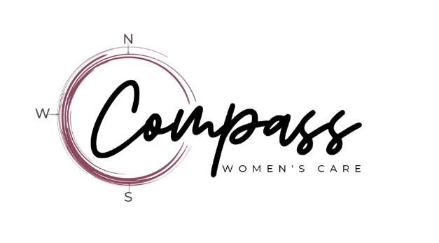
Donations are earned by our clients through our “Earn While Your Learn” parenting curriculum program. Thank you for your donations.

Material Donations
Our current, most needed items are:
- Baby wipes (tubs and refill packages)

OTHER DONATIONS WE ACCEPT:
- Unopened packages of Diapers (newborn – size 6)
- Baby wipes (tubs and refill packages)
- New outfits (newborn to 3-9 months)
- Long and short-sleeved onesies and sleepers
- Baby toiletry items (diaper cream, soap, lotions, powder, shampoo, etc.
- (We do not accept baby powder)
- Socks, bibs, hats
- Washcloths, hooded towels
- New Teething toys
- Baby Monitors

GENTLY USED, LIKE NEW, ITEMS:
- Clothing (newborn – 2 years)
- Baby bath items (hooded towels, washcloths, etc.)
- Large items:
    - Baby Bath Tubs
    - Bouncy Seats
    - Bumbo Seats
    - Infant Slings
    - Pack & Play
    - Strollers
    - Books (current, complete and like-new)
    - Limited maternity clothing, current fashions only

WE REGRET THAT WE CAN NOT ACCEPT:
- The following used items:
  - pacifiers
  - teething toys
  - feeding utensils
  - stuffed animals
  - car seats
  - changing tables
  - bassinets
  - cribs
  - used or open containers of formula and baby food
- Any recalled item, even if new.
- Used mattresses
- Used breast pumps
- Items that are stained, incomplete, too worn or outdated

